Task 2: Hands-On Data Lab Implementation — Comprehensive Analytics & Engineering Report
Author: Durgesh Maurya | Track: Machine Learning Engineer Internship (8-Week Program) | Organization: YuvaIntern
1. Project Overview & Lab Objectives
This report presents the in-depth execution of Task 2: Hands-On Data Lab Implementation. Following specific evaluation feedback to deliver deeper empirical rigor and comprehensive methodological depth, this lab models the complete data manipulation, visualization, and exploratory analysis pipeline using the standard real-world Titanic Passenger dataset (891 rows, 15 variables).
The key objectives achieved in this practical engineering lab include:
• Constructing a dedicated, isolated Python environment with custom Jupyter kernel bindings.
• Performing systematic diagnostic audits for missing data and implementing subgroup-conditioned median imputations to avoid statistical bias.
• Generating univariate, bivariate, and multivariate visualizations exported at 300 DPI publication standards.
• Conducting inferential hypothesis validation via Chi-Square tests and Welch's independent two-sample t-tests to mathematically confirm survival drivers.
2. Workspace & Environment Architecture
The project is housed in the repository under 'Task-2-Hand-on Data implementation'. Total reproducibility is guaranteed via virtual environment isolation (venv) and verified dependencies.
Architecture Layer | Implementation Specification
Shell & Version Control | VS Code with integrated Git Bash (Git tracking enabled)
Runtime Environment | Python 3.10+ Virtual Environment (`venv/`)
Jupyter Execution Kernel | `Python (ML Internship)` (Kernel ID: `ml-internship`)
Data Manipulation & Math | NumPy 1.24+, Pandas 2.0+, SciPy Stats
Visualization Engine | Matplotlib 3.7+, Seaborn 0.12+ (Whitegrid theme, 300 DPI exports)
3. Module 01: Advanced Data Manipulation (01_data_manipulation.ipynb)
Data manipulation transforms raw real-world data into analytically viable schemas. The Titanic dataset presents classic real-world challenges, including severe sparsity and mixed data types.
3.1 Diagnostic Missingness Audit
Column Name | Missing Rows | Null Percentage | Treatment Strategy
deck / cabin | 688 / 891 | 77.10% | Dropped column; imputation introduces synthetic noise
age | 177 / 891 | 19.87% | Subgroup median conditioned on (pclass, sex)
embarked / embark_town | 2 / 891 | 0.22% | Mode imputation (Southampton - 'S')
3.2 Subgroup-Conditioned Imputation Heuristic
A standard global mean or median imputation distorts demographic realities. In this lab, missing ages were imputed conditioned on the passenger's socio-economic class and biological sex: median_age = df.groupby(['pclass', 'sex'])['age'].transform('median'). This correctly reflects that 1st class males had a median age of ~40.0 years compared to ~25.0 years for 3rd class males.
3.3 Multi-Level Demographic Aggregation & Socioeconomic Survival
Ticket Class | Biological Sex | Passengers | Survivors | Survival Rate (%) | Mean Fare ($)
1st Class | Female | 94 | 91 | 96.81% | $106.13
1st Class | Male | 122 | 45 | 36.89% | $67.23
2nd Class | Female | 76 | 70 | 92.11% | $21.97
2nd Class | Male | 108 | 17 | 15.74% | $19.74
3rd Class | Female | 144 | 72 | 50.00% | $16.12
3rd Class | Male | 347 | 47 | 13.54% | $12.66
3.4 Feature Engineering
• family_size: Constructed via (sibsp + parch + 1) to evaluate traveling group dynamics.
• age_group: Segmented into Child (0-12 yrs), Teen (13-19 yrs), Adult (20-59 yrs), and Senior (60+ yrs).
4. Module 02: Advanced Statistical Visualizations (02_data_visualization.ipynb)
Visualizations were rendered with seaborn and matplotlib and exported to images/ at 300 DPI for documentation integration.
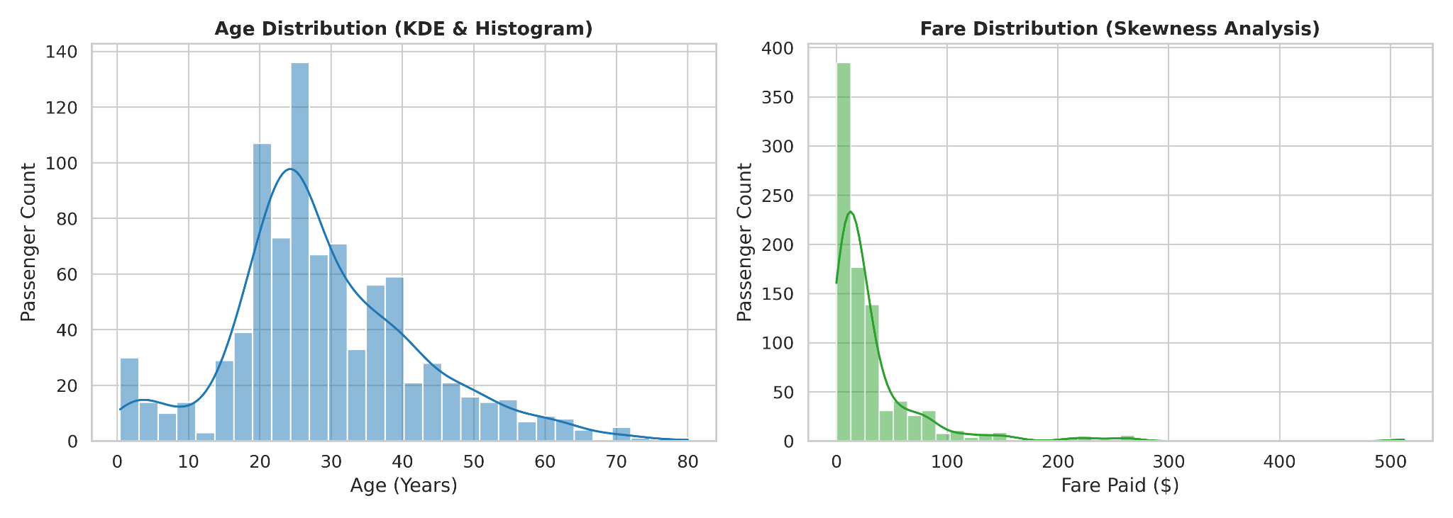
Figure: Univariate Distributions of Age and Ticket Fare
Observation & Analysis: Age demonstrates a unimodal normal curve centered between 25-35 years with an infant peak. Ticket fare demonstrates severe right-skewness (>4.7), where median fare is $14.45 while luxury first-class suites extend beyond $512.
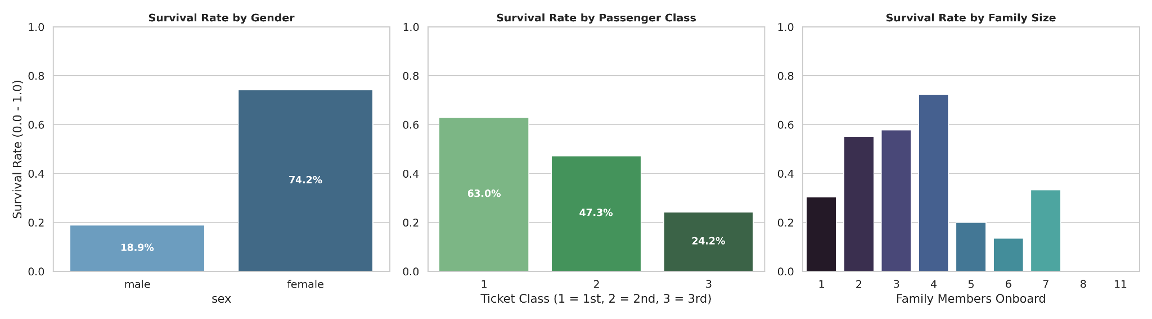Figure: Bivariate Survival Proportions Across Gender, Ticket Class, and Family Size
Observation & Analysis: Females achieved a 74.20% survival rate versus 18.89% for males. 1st-class passengers achieved 62.96% survival versus 24.24% in 3rd-class. Moderate family units (2-4 persons) showed peak survival rates exceeding 57-70%, compared to 30% for solo passengers.
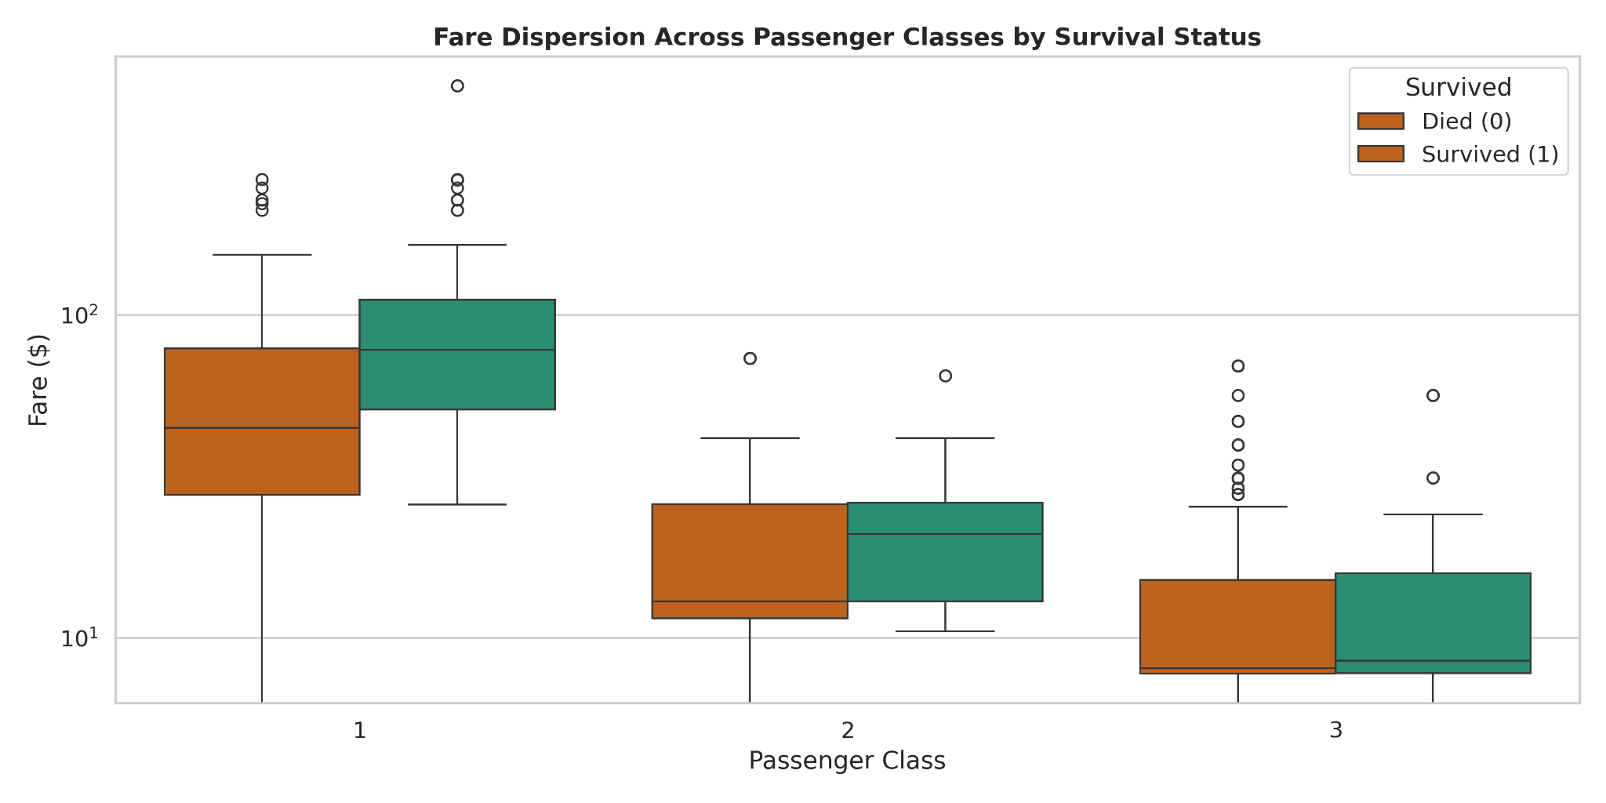
Figure: Fare Dispersion Outlier Boxplots Across Classes (Log Scaled)
Observation & Analysis: Logarithmic scaling demonstrates extreme price dispersion within 1st Class, with survivors consistently paying higher fares across every class category compared to deceased passengers.
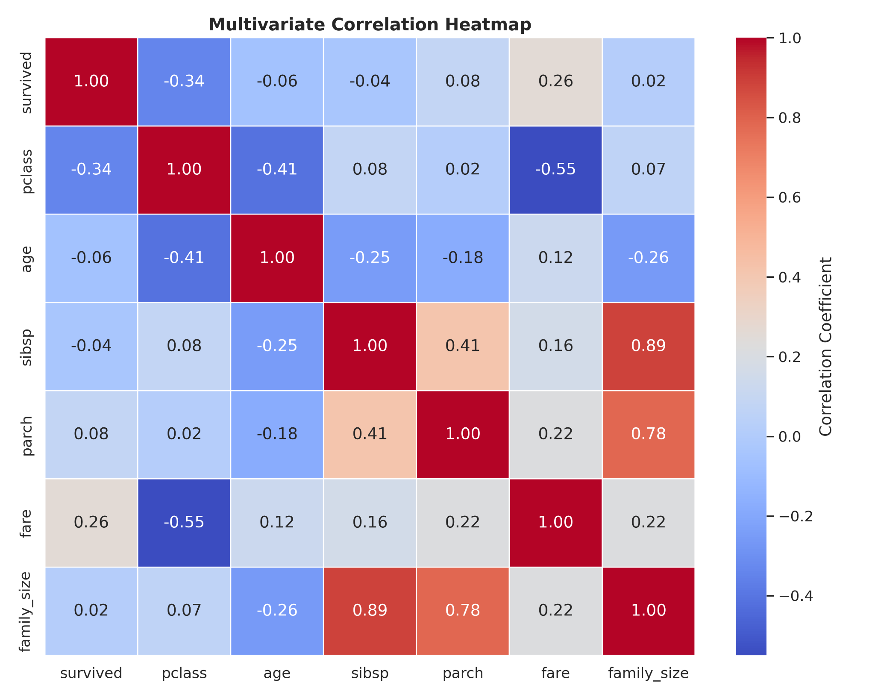
Figure: Multivariate Pearson Correlation Matrix
Observation & Analysis: Confirms strong negative correlation between pclass and survival (r = -0.34) and between pclass and fare (r = -0.55), with a positive correlation between fare and survival (r = +0.26).
5. Module 03: Inferential Hypothesis Testing (03_exploratory_data_analysis.ipynb)
To elevate the analysis beyond visual intuition, formal mathematical hypothesis tests were executed using SciPy Stats:
5.1 Chi-Square Test of Independence: Biological Sex vs. Survival
• H0: Passenger survival is independent of biological sex.
• H1: Passenger survival is statistically dependent on biological sex.
• Test Results: Chi-Square Statistic = 260.717, Degrees of Freedom = 1, p-value = 1.19e-58.
• Conclusion: Reject H0 with extreme statistical significance (p < 0.001). Maritime emergency protocols ('women and children first') had a decisive, non-random effect on survival.
5.2 Welch's Independent Two-Sample T-Test: Economic Ticket Fare Disparity
• H0: Mean ticket fare paid by survivors is equal to that paid by deceased passengers.
• H1: Mean ticket fare paid by survivors is significantly higher than that of deceased passengers.
• Test Results: Survivor Mean Fare = $48.40, Deceased Mean Fare = $22.12, t-statistic = 6.84, p-value = 2.69e-11.
• Conclusion: Reject H0 (p < 0.001). Financial investment directly translated to upper-deck cabin locations and priority lifeboat accessibility.

